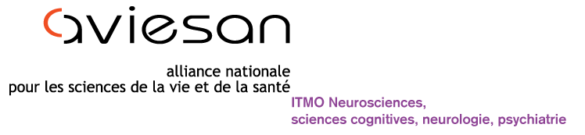




2020-2021 call for proposals

« Diseases of the vision: origins and treatments »

Application file

The full application file must be emailed at the following address:

deficience-visuelle.daf@inserm.fr

Before September 3, 2020, midnight Paris time.

Content

Content 2
General informations 3
Part I 3
1-1 Civil status of the project coordinator 3
1-2 Project ID 4
1-3 Abstract ; Keywords 5
1-4 CV of the coordinator (2 pages max) including five relevant publications within the last five years 6
Part II 7
2-1 Scientific project (3 pages max) 7
2-2 Other teams informations (total number of teams should not be >3) 8
2-3 Budget justification 9
2- 4 Other funding requested, obtained or ongoing on the same project 9
Part III 10
Project Coordinator 10

General informations

The Association UNADEV (Union Nationale des Aveugles et Déficients Visuels; National Union of the Blinds and Visually Impaired) signed a partnership agreement with ITMO NNP (Multi-Organism Thematic Institute Neurosciences, cognitive sciences, neurology and psychiatry from the national alliance for life science and health (AVIESAN)) in order to participate in funding of research in the field of vision.

The topic of the call for proposals for 2020 - 2021 is “Diseases of the vision: origins and treatments”

Eligibility and assessment criteria are described in the document Call for proposals:

Part I

1-1 Project coordinator and laboratory

Last name of the project Coordinator
First name of the project Coordinator
Name of the research laboratory and Institute
Name of the Head of the laboratory
Name of the Team leader
Laboratory postal address
City

1-2 Project ID

Acronym
Project title
Scheduled length of the project (up to 36 months)
Total funding requested (up to 200 k€)

1-3 Abstract; Keywords

Abstract (max 2000 characters space included):

Keywords (5):

Résumé grand public en français (max 2000 caractères) will be published if the project is funded.

1-4 CV of the coordinator (2 pages max) including five relevant publications within the last five years

Part II

2-1 Scientific Project (3 pages max)
Description of the working programme including the objectives, the rationale, the methodology highlighting the novelty, originality and feasibility as well as the contribution of the expected results to the research field. A brief description of the milestones and the schedule of the project should be provided.

2-2 Other teams informations (total number of teams should not be >3)

Team 2 (if relevant)
Last name
First name
Name of the research laboratory
Name of the Head of the laboratory and Institute
Name of Team leader
Laboratory postal address
City

Team 3 (if relevant)
Last name
First name
Name of the research laboratory and Institute
Name of the Head of the laboratory
Name of the Team leader
Laboratory postal address
City

2-3 Budget justification

Maximum total budget requested: 200 k€ HT (up to 3 years)

Type of expenditure | Year 1 | Year 2 | Year 3
Staff (technician, engineer, phD student, post-doctoral researcher) | Euros | Euros | Euros
Consumables | Euros | Euros | Euros
Equipment | Euros | Euros | Euros
Others (Missions and other direct costs of the project). | Euros | Euros | Euros

Total budget requested | Euros | Euros | Euros

2- 4 Other funding requested, obtained or ongoing on the same project

Part III

The application will be signed by the scientific coordinator of the project and its laboratory director and joined as a pdf.

Project Coordinator

Signature of the project coordinator
I the undersigned, last and first name of the project coordinator:

confirm the accuracy of the information provided in the application file.

Signature : Signed in on

Signature of the director of the laboratory that hosts the project coordinator
I the undersigned, last and first name of the director of the laboratory:

authorize Dr

to develop and coordinate this project and allow this person to carry it out.

Signature : Signed in on

